Nap-in/Laundry Hour and Climate Storytime Toolkit

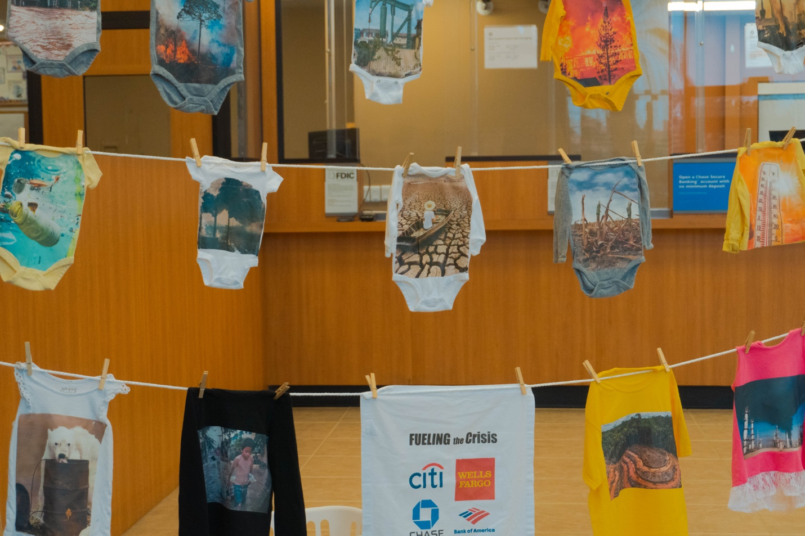

Table of Contents
Organizing a Story Hour and Nap-in 1
Story-hour and Nap-in Flyer 3
Mr. D Lives in a Bubble 5
Revised Children’s Songs 8

Organizing a Story Hour and Nap-in

It’s fun to organize a Climate Story Hour and Nap-In!
Here is an outline of the steps we took and some resources that you are free to adapt for your event.
- Gather a small group of people who would like to participate in a non-violent disruption of business as usual in order to draw attention to the role of the banking industry in financing the climate crisis. (You may have other targets in mind and that’s good too.)
- Scout possible locations. We looked for a site that had a nice open space for our group and very little security personnel.
- Check out hopeful books about the climate from your local library, particularly designed for younger readers. Some of our favorites are shown below.
- We also had fun making blankets using artwork created by some of the participants.
- Develop a brief plan for your action. We kept ours short and sweet, to be both covid-safe, and easy for people with busy lives and/or short attention spans.
- Have a brief online meeting before the action to review the plan. We also set up a Signal chat to keep people updated.
- Create a handout to explain what you are doing and why. This is helpful to give to staff, clients, or passersby. Our handout is in the resources for you to adapt if you wish.
- Designate one or two people in your group to talk to staff and security as needed.
- Ask someone to photograph or video your action and get agreement from participants to be photographed.
- This is what we did at the action:
- Gathered near the site with pillows, blankets, and books.
- Entered the site together and formed a loose circle on the floor.
- Welcomed everyone and then began a few minutes of silent reading.
- Invited participants to share briefly from their books.
- Read aloud the story of Mr. D. Lives in a Bubble, written specifically for Chase bank. The story and illustration are included in our resources for you to use or adapt if desired.
- Moved into napping after sharing several reasons why we are SO tired of business as usual.
- After napping for several minutes, participants woke up and shared hopeful next steps. Then we picked up our blankets, pillows, and books and left the site.
- Lastly, post images/video if desired (see our video on xrlosangeles.org)
Alternatives

- Another option is to create a laundry hour and nap-in (see video on xrlosangeles.org)
- Instead of reading stories we sang while hanging laundry on a makeshift clothesline (photo above)
- After the laundry was hung, we proceeded to take a nap

Story-hour and Nap-in Flyer/Handout
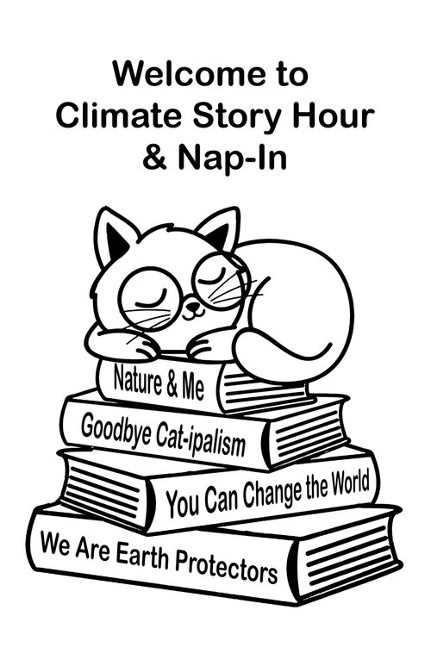
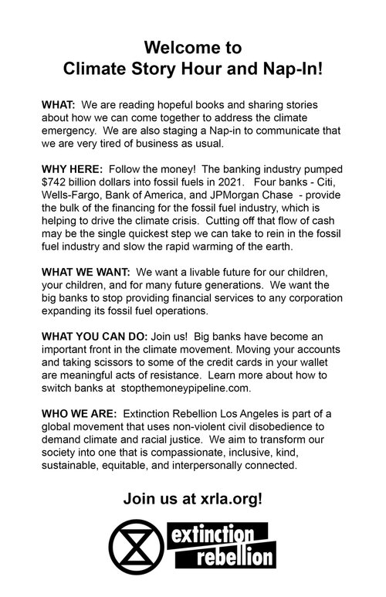

Mr. D Lives in a Bubble

Mr. D is the head of a big bank and he lives in a bubble!
The bubble is very shiny and when you first see it, living in a bubble looks like fun.
But living in a bubble makes it hard to connect with other people.
Oh no!
Living in a bubble means Mr. D can’t see clearly how the actions of his bank are hurting people and animals all over the earth.
Living in a bubble confuses you too! It can make you think that making more and more money is more important than taking good care of all the living things around you.
Oh no!
Mr. D has a family that he cares deeply about but living in his bubble he can’t see how what he and his bank are doing will impact his children, grandchildren, and all future generations.

Mr. D needs our help!
Sometimes when people are not acting nice, we need to get our friends together and tell them to stop.
Let’s tell Mr. D that we like him but his bank needs to stop giving money to companies that are hurting the earth.
STOP, Mr. D! You will be sad in the future about the damage you have caused and we don’t want you to feel sad.
STOP, Mr. D! We are your friends and we are going to do everything we can to help you and all the other people in the financial industry to get out of your bubbles and do the right thing.
And that is why we are here today! We have come together because we want big changes! What else are we tired of?
We are tired of… We are tired of… We are tired of…
Creating the world we want to live in is a big job, but together, with all of our friends and families, we can do it!
We will also need to take good care of ourselves and get lots of rest to be strong enough to insist on the big changes our world needs right now.
Let's take a few minutes to rest and think about our next steps.
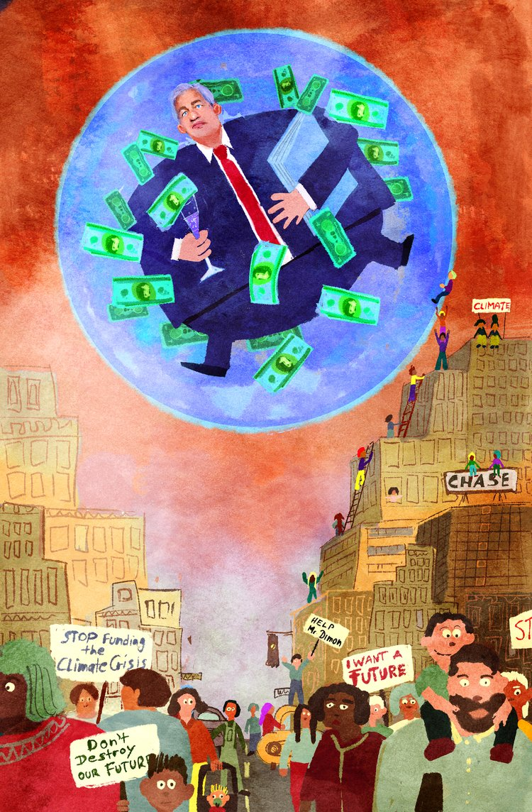

Revised Children’s Songs

Laundry Line Song
(Sung to the tune of “The Wheels on the Bus”)

The weather is getting very hot
Very hot
Very hot
The weather is getting very hot
All through the earth

Fossil fuels are killing us
Killing us
Killing us
Fossil fuels are killing us
All through the earth

The banks invest in fossil fuels
Fossil fuels
Fossil fuels
The banks invest in fossil fuels
And Chase is the worst

The mothers of the world say
DIVEST NOW (loudly!)
DIVEST NOW
DIVEST NOW
The mothers of the world say DIVEST NOW
Chase, DIVEST NOW

We want a future for all the children
All the children
All the children
We want a future for all the children,
and generations to come

We won’t go quiet and we’ve got hope
We’ve got hope,
We’ve got hope,
We won’t go quiet and we’ve got hope,
Together we are strong

Your dirty laundry makes us sick
Makes us sick
Makes us sick
Your dirty laundry makes us sick
We need a nap

Alternative verses

Temperatures are rising more and more,
more and more,
more and more,
Temperatures are rising more and more,
All through the town.

Massive floods wash everything away,
everything away,
everything away,
Massive floods wash everything away,
Millions have no homes.

Wildfires rage, burning trees and homes,
trees and homes,
trees and homes,
Wildfires rage, burning trees and homes,
All around the globe.

In 2022, we’ve had record breaking drought,
record breaking floods,
record breaking fires,
In 2022, we’ve had record breaking heat,
What is going on?

Climate emergency is here and now,
it’s getting worse,
here and now,
Climate emergency is here and now,
Let’s talk about why.

Investors, Insurers and most big banks,
most big banks,
most big banks
Investors, insurers and most big banks,
All are to blame

Chase, Wells Fargo, and Citi Bank,
B of A and
Citi Bank,
All loan trillions to oil and gas,
Fueling climate change.

Black Rock, Vanguard, and pension funds,
pension funds?
pension funds!
Investors bankroll the industry
Making matters worse.
Billions of dollars in profits made
profits made
profits made
Billions of dollars in profits made
While communities are destroyed

The most affected people and places,
People and places,
People and places,
The most affected people and places
Didn’t create this mess

Wall street greed has got to stop
Got to stop
Got to stop
Wall street greed has got to stop
It’s the only chance we’ve got.

Big changes are needed, and we can’t wait,
We can’t wait,
We can’t wait,
Climate Justice is our demand
That’s why we’re here.

We want a future for all the children
North and south
East and west
We want a future for all our children,
and generations to come.

We’re tired of hanging on these lines
The dirty laundry,
From your crimes
We’re tired of hanging on these lines
We need a nap!

We won’t go quiet, and we’ll be back
We’ve got hope,
And we’ll be back,
We won’t go quiet, and we’ll be back
Together we are strong

The Big Greedy Drillers
(Sung to the tune of “The Itsy Bitsy Spider”)

Oh the Big Greedy Drillers took the oil from the ground
They made the climate crisis and the spread it all around
They knew what they were doing and they knew it’d cause us pain,
But they needed all the oil for their factories and their planes.
Well the people we were watching and we saw what they’re about,
Up rose the people and froze Big Oil out!
Out came the sun, and it powered all their planes,
And the people and the planet went about our lives again.

(Brahm’s) Lullaby

Lullaby. Now it’s time. To nap in for what’s right.
Tired from hanging on these lines, the dirty laundry from your crimes.
Mommy’s here to hold you near, and work through your fear.
Through my love, may you find, dreams of a greener life.

